January 5, 2021

Dear Marnice,
Congratulations on your successful election to the Student Government Association (SGA) Executive Team. You have chosen to begin or continue your involvement with the McDaniel SGA at a very transformative time in its history and I look forward to seeing where your leadership takes this association which is at the heart of student life at McDaniel.
The following SGA Vision Statement is meant as a guide for your upcoming work and is hopefully one of the first steps in the collaborative work that we will begin together. With the College’s support, I encourage you to build an SGA that represents McDaniel students to its fullest.

Sincerely,
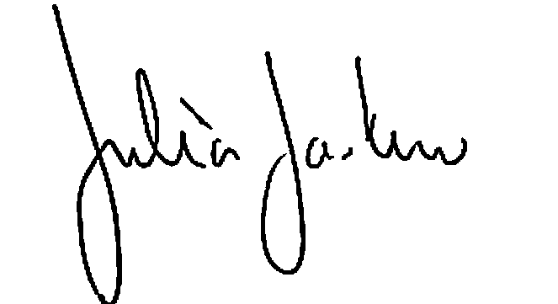
Julia Jasken
Executive Vice President/Provost

McDaniel College Student Government Association Vision Statement
McDaniel College’s vision for the Student Government Association is to serve as the official communication and advocacy channel for the student community.
In order to do this effectively, the SGA should:
- Possess a thorough understanding of the structure of the College including its strategic plan initiatives, the functional areas/divisions that comprise the College, and their roles on campus.
- Endeavor to accurately represent and advocate for the diverse voices of the student body.
- Seek input and listen to perspectives on student-related matters while serving as a forum for discussion regarding issues and concerns.
- Serve as a role model for campus organizations and students in regard to leadership, inclusiveness, effectiveness and personal conduct.
The SGA facilitates communication between the student community and the College. They represent the students and work collaboratively with the College on the following:
- The SGA president represents the student body on the Board of Trustees and shares information with the general student population after every meeting.
- The SGA facilitates the Ask McDaniel Anything series and/or other regular community forums with college representatives to listen to students and gather feedback.
- The SGA meets on a monthly basis with the dean of students and/or relevant vice presidents.
- The SGA president and vice-president meet with the president council/cabinet at least once a semester
- The SGA communicates regularly with the student editors of the McDaniel Free Press, the TV production club, radio station, and/or any other relevant student media organizations approved by the Office of Student Engagement (OSE).
- The SGA actively works with their advisors to update and maintain their Constitution and Bylaws and hold regularly scheduled elections, with widespread student body participation.
In order to represent diverse student voices, the College encourages the SGA to establish an organizational structure that includes stakeholders from the varied aspects of student life at McDaniel. These areas/groups may include but are not limited to:
- ODEI Cultural Leadership Council
- Student Athletic Advisory Council
- Resident Assistant
- Career Peer (CEO)
- Peer Mentor
- McDaniel Local Leader
- Greek Life
- Student Alumni Advisory Council
- McDaniel Ambassadors (Admissions)
- Engagement Peer
- Student Organization Leadership
- Students involved in sustainability efforts

